Stock and ecommerce

**BY**

**Saiful Islam**

**ID: 171-15-897**

**And**

**Jannatul ferdaus**

**ID:171-15-897**

This Report Presented in Partial Fulfillment of the Requirements for the Degree of

Bachelor of Science in Computer Science and Engineering

**Supervised By**

**Ms. Monirul Islam**

**Lecturer**

Department of CSE

Daffodil International University



**DAFFODIL INTERNATIONAL UNIVERSITY**

**DHAKA, BANGLADESH**

**27th March2021**

**DAFFODIL INTERNATIONAL UNIVERSITY**

**DHAKA, BANGLADESH**

**APRIL 2021**

**APPROVAL**

This Project titled **“DESIGN AND DEVELOPMENT** **OF MULTI VENDOR E-COMMERCE** **WEBSITE NAMED EMA-JHON SHOP: ONE STOP E-COMMERCE SOLUTION”**, submittedby SUBRINA RAHMAN, ID No: 171-15-846 and SIRATUM MONIRA, ID No: 171-15-828 to the Department of Computer Science and Engineering, Daffodil International University has been accepted as satisfactory for the partial fulfillment of the requirements for the degree of Bachelor of Science in Computer Science and Engineering and approved as to its style and contents. The presentation has been held on 01.03.2021.

**BOARD OF EXAMINERS**

https://lh5.googleusercontent.com/MbK453BOoQb_y4U9La2A6XhjEaqCBDPcAHi-Su40W9gs-In7op1sp_-o8OJ3-rPKnYWn6DX7H8RzTzrtmBedc4wj1B90MJNfsL6z7TAkatu4qVrxriDIAAyE-ZSDIuWAovDcIso

|  |  |
| --- | --- |
| **____________________________** |  |
| **Dr. Syed Akhter Hossain** | **Chairman** |
| **Professor and Head** |  |
| Department of Computer Science and Engineering |  |
| Faculty of Science & Information Technology |  |
| Daffodil International University |  |
| **____________________________** |  |
| **Dr. S. M. Aminul Haque** | **Internal Examiner** |
| **Associate Professor** |  |
| Department of Computer Science and Engineering |  |
| Faculty of Science & Information Technology |  |
| Daffodil International University |  |
| **___________________________** |  |
| **Ohidujjaman** | **Internal Examiner** |
| **Senior Lecturer** |  |
| Department of Computer Science and Engineering |  |
| Faculty of Science & Information Technology |  |
| Daffodil International University |  |
| **____________________________** |  |
| **Dr. Mohammad Shorif Uddin** | **External Examiner** |
| **Professor** |  |
| Department of Computer Science and Engineering |  |
| Jahangirnagar University |  |

https://lh4.googleusercontent.com/vVMzr79NLixzNchQwZ2Qqvx_XLZbPHqxhI40NXwJ5ONuqKsmOhvcUUKbDNYj_ZugJkaw1WWkSx8Yi90XqTRs1Gb36pzKPCvBynEeKWx6DrPMqa3bPmttj_n2l4kMW2f6j6M-nyEhttps://lh6.googleusercontent.com/oTrpBvg-x6Bej8ls-HGtPIJ2fmdKXJ37dKSQfflqZsLhEBGQR3ERUAAVC-uF9OmWiBaRwDqDcbX8MxRrOIGMST_j2QKF097az5hXA0u5Bd0qTxuxKFxoiLLQIq5bP2AqPBNgc9Y

DECLARATION

We consider that this project has been done by us under with the processing of our CSE Daffodil International University Lecturer Ms. Shayla Sharmin. We would like to further add that this project or any allocation for this project has not been submitted for omnipotent appreciation of any degree anywhere else.

**Supervised by**

**Md. Monirul Islam**

Lecturer

Department of CSE

Daffodil International University

**Submitted by:**

**Saiful Islam**

ID: 171-15-897

Department of CSE

Daffodil International University

**Jannstul ferdaus**

ID: 171-15-897

Department of CSE

Daffodil International University

**ACKNOWLEDGEMENT**

At the beginning I am very much grateful to almighty God for giving me strength and opportunity and sound mind to complete the project named as Digital e-commerce report. I would like to categorize my sincere feelings to my respected supervisor Md. Monirul Islam, Lecturer in Computer Science and Engineering. Without her continuous guidance and persistent help, this project would not have been a success for me. I want to thank Ben White for his contribution in completion of this project. I am grateful to the Daffodil International University, Sacramento and the department of Computer Science without which this project would have not been an achievement. I also thank my family and friends, for their endless love and support throughout my life.

**ABSTRACT**

E-commerce is the new opportunity in business nowadays,And the need of a good e-commerce site has been felt badly as the harrasment in e-commerce sites for the lack of quality design and effectiveness is a main problem in spreading popularity of e-commerce sites. Having an own site is a significant piece of our online business procedure. It is an extraordinary route for us to develop our image, obtain steadfast clients, acquire new experiences, and get innovative with our promoting. Broadening where we sell online can help us arrive at new clients, particularly as internet business turns out to be more serious we need to upgrade the quality of our sites where we are lacking

|  |  |  |  |  |
| --- | --- | --- | --- | --- |
|  |  | **TABLE OF CONTENTS** |  | |
| **CONTENTS** | | | **PAGE** | |
| Title Page | | | i | |
| Board of Examiners | | | ii | |
| Declaration | | | iii | |
| [Acknowledgement](https://docs.google.com/document/d/1Axyq7ltrubJ_UuSvwZAasxR7EKIExXP7/edit#bookmark=id.tyjcwt) | | | [iv](https://docs.google.com/document/d/1Axyq7ltrubJ_UuSvwZAasxR7EKIExXP7/edit#bookmark=id.tyjcwt) | |
| Abstract | | | v | |
| List of Tables | | | viii | |
| List of Figures | | | ix | |
| **CHAPTER** | | |  | |
| **CHAPTER 1: INTRODUCTION** | | | **1-2** | |
| 1.1 | Introduction | | 1 | |
| 1.2 | Project Motivation | | 1 | |
| 1.3 | Problem statement | | 2 | |
| 1.4 | Methodology | | 2 | |
| 1.5 | Summary | | 2 | |
| **CHAPTER 2: BACKGROUND** | | | **3-4** | |
| 2.1 |  | Introduction | 3 | |
| 2.2.1 | | Introduction of Development Platform | 3 | |
| 2.2.2 | | Database Platform | 3 | |
| 2.2.3 | | Introduction of database | 4 | |
| 2.2.4 | | Scope | 4 | |
| 2.2.5 | | Study Of feasibility | 4 | |
| **CHAPTER 3: REQUIREMENT SPECIFICATION** | | | **5-10** |  |
| 3.1 | Introduction | | 5 |  |
| 3.2 | Hardware Requirements | | 5 |  |
| 3.3 | Software Requirements | | 5 |  |
| 3.4 UML Diagram | | | 6 |  |
| 3.4.1 Use Case Diagram | | | 6 |  |
| 3.4.2 Description Use Case Diagram | | | 7 |  |
| 3.5 | Data flow diagram | | 8 |  |
| 3.6 ER Diagram | | | 9 |  |
| 3.7 | Design Requirement | | 10 |  |
| 3.8 Summary | | | 10 |  |

|  |  |  |
| --- | --- | --- |
| **CHAPTER 4: DESIGN SPECIFICATION** | | **11-17** |
| 4.1 Front-End-Design | | 11 |
| 4.2 Back-End Design | | 11 |
| 4.2.1 | Admin Login Page | 11 |
| 4.2.2 | Vendor Log In Page | 12 |
| 4.2.3 | Admin & vendor Dashboard | 12 |
| 4.2.4 | Front Page | 13-15 |
| 4.2.5 | Category | 16 |
| 4.2.6 | Product Upload Page | 16 |
| 4.2.7 | Order confirmation page | 17 |
| 4.2.8 | Order Details Page | 17 |

|  |  |  |
| --- | --- | --- |
| **CHAPTER 5: IMPLEMENTATION AND TESTING** | | **18-20** |
| 5.1 | Introduction | 18 |
| 5.2 | Database | 18 |
| 5.3 | Implementation of back-end design | 19 |
| 5.4 | Testing Implementation | 19 |
| 5.4.1 Unit Testing | | 19 |
| 5.4.2 Integration Testing | | 20 |
| 5.4.3 Functional Testing | | 20 |

|  |  |  |
| --- | --- | --- |
| **CHAPTER 6: CONCLUSION & FUTURE SCOPE** | | **21** |
| 6.1 | Discussion & Conclusion | 21 |
| 6.2 | Scope and Further Development | 21 |

|  |  |
| --- | --- |
| **REFERENCES** | **22** |
| **PLAGIARISM REPORT** | **23-24** |

|  |  |
| --- | --- |
| **LIST OF FIGURES** |  |
| **FIGURES** | **PAGE NO** |
| Figure 3.4.1: Use case of multivendor marketplace shopping system | 6 |
| Figure 3.5: Data Flow Diagram | 8 |
| Figure 3.6: Er-diagram | 9 |
| Figure 4.2.1: Admin Log In Page | 11 |
| Figure 4.2.2: Vendor Log In Page | 11 |
| Figure 4.2.3: Admin and vendor dashboard page | 12 |
| Figure 4.2.4: Front Page | 13-15 |
| Figure 4.2.5: Category List Page | 16 |
| Figure 4.2.6: Product Upload Page | 16 |
| Figure 4.2.7: Order Confirmation Sheet | 17 |
| Figure 4.2.8: Order Details Page | 17 |
| Figure 5.2: Database Connection | 18 |

**CHAPTER 1**

**INTRODUCTION**

**INTRODUCTION**

**1.1 About the Project**

Web based business (Electronic Commerce) is cycle of working together through PC organizations. The essential objective of an internet business website is to sell merchandise and enterprises on the web. Web based shopping is a type of electronic shopping store where the purchaser is straightforwardly online to the merchant's PC generally through the web. An individual sitting on his seat before a PC can get to every one of the offices of the Internet to purchase or sell the items. Internet Shopping System helps in purchasing of merchandise, items and administrations online by picking the recorded items from website(E-Commerce webpage). The Shopping truck is primarily valuable for who haven't time to go to shopping. Shopping basket is a vital component utilized in internet business to help individuals making buys on the web. The deal and buy exchange is finished electronically and intelligently progressively. Client can login into eCommerce site, when he signed in then naturally one shopping basket will be made, when client select a thing it will add to truck. On the off chance that client thinks the chose thing isn't valuable for him, at that point he can erase that thing structure the cart.Report age highlight is given utilizing Crystal Reports to create various types of reports like visual diagrams, pie graphs and table sort outlines and so forth

The proposed framework helps in building a site to purchase, sell items or merchandise web based utilizing web association. Not at all like conventional trade that is completed truly with exertion of an individual to proceed to get items, eCommerce has made it simpler for human to diminish actual work and to save time. The essential idea of the application is to permit the client to shop for all intents and purposes utilizing the Internet and permit clients to purchase the things and articles of their longing from the store.E-trade is quick making strides as an acknowledged and utilized business worldview.

Increasingly more business houses are carrying out site giving usefulness to performing business exchanges over the web. Internet business sites gives shoppers more affordable items and administrations by permitting them to shop in numerous spots and lead brisk correlations. Web based business which was begun in mid 1990's has taken an incredible jump in the realm of PCs, however the way that has thwarted the development of internet business is security. Client chose a few things, yet in his credit or charge truck haven't that much equilibrium, at that point he was logout from the site, the chose things are put away at truck with explicit clients with his dispensed trucks, after certain days he purchased those things at that point naturally erased from the truck.

Shopping basket System is the Simple shopping Solution. In everyday life, we should purchase loads of merchandise or items from a shop. Client can login and get different data about item and can buy the appropriate product.It might be food things, electronic things, house hold things and so on and so forth Client can pay on the web, so security is should accordingly eCommerce site give secure exchanges. Presently a days, it is truly difficult to get some an ideal opportunity to go out and get them without anyone else because of occupied way of life or heaps of works. To tackle this, B2C E-Commerce sites have been begun. Utilizing these sites, we can purchase merchandise or items online just by visiting the site and requesting the thing on the web by making installments online.After deal eCommerce site additionally give after deals administration in which client issue is addressed.

**1.2 The Problem Statement**

Almost the sites in bangladesh nowadays are seem to be copied as they don’t have unique design and the trust issue of the customer raises here

Each site overhaul accompanies exceptional obstacles to survive, however online business sites have numerous special issues that most different sites don't confront.

Here are a few hints for tending to these issues just as focuses to consider as you track down the correct website composition group for your web based business webpage.

Each site should give clients a suspicion that all is well and good. This is particularly valid for web based business sites, which ordinarily request that clients give their place of residence and Visa data to finish their buy.

Regardless of whether a client is keen on the items you give, they aren't probably going to finish a buy on the off chance that they feel that your site isn't secure. They may stress over things like malware, fraud, and circulation of their own data. 77% of individuals are worried about somebody taking their data on the web, and they are hyper-mindful of this worry when visiting a website that unequivocally requests their own data.

77% of clients are worried about fraud. It's dependent upon you to fabricate trust.

This implies that your web based business site needs to go to remarkable lengths to set up trust with the client. You need to discover and address each possible quality of your site that could prompt doubt.

Warnings in internet business include:

A site that isn't streamlined for versatile. The greater part of the guests to your online business site will be perusing on their cell phones. In the event that your webpage isn't upgraded for these clients (which means you don't have a responsive site or a form of your site that is portable cordial), almost certainly, a considerable lot of your versatile clients will leave the website before they even start perusing your items.

A site that takes too long to even think about stacking. While this website composition no-no is unappealing to clients on any sort of webpage, a too-moderate internet business site can really prompt a feeling of doubt with the clients. All in all, how lethargic is excessively sluggish? 41% of clients will leave your site in the event that it requires over 5 seconds to stack.

Standards, advertisements, and pop-ups. Besieging your clients' screens with commercials and huge standards will just deter them from visiting your item pages. This is particularly obvious on cell phones, where a straightforward spring up (that you may believe is little) takes up most of the client's screen.

Exploitative publicizing. It tends to be not difficult to utilize duplicate and offers that urge clients to make a buy with you. In any case, is that duplicate genuine? For instance, on the off chance that you publicize on your site that you give "Free U.S. Transportation," your clients will expect any request delivery to the U.S. to have free transportation. Adding on a charge afterward in light of the fact that you neglected to explain "on orders more than 50 taka," will baffle your clients and cause you to lose their trust.

Absence of safety verification and trust marks. Guests to your site need outsider verification that it's safe. On the off chance that you get a SSL authentication for your site, a confirmed "Secure" catch will show up close to your URL. This gives clients sure confirmation that you're offering them a safe site.

Inferior quality or unessential item pictures. Does it resemble your item photographs were randomly shot in a dim, stale smelling room? This is certifiably not a decent visual to ship off clients who like to realize that the item they're going to buy is in spotless and immaculate condition.

Malicious item depictions and copywriting. Clients don't care for spam, regardless of how much an entrepreneur may think those malicious watchwords will help their SEO. Nasty and low quality substance is a quick method to make a client re-think the reliability of your site.

Absence of web-based media accounts. It very well may be a commendation when a client visits your site and afterward needs to look at you via online media. In the event that they can't discover you anyplace via online media, that endeavored praise can out of nowhere transform into the client addressing how authentic your business is. You don't need to be accessible on each web-based media stage, however deliberately picking a couple of records will help build up your validity.

**1.4 Methodology**

This online stock system project is carried out through the following phases-

* Login and modification module for shop owner

* Login and selling module for employee

* Buying module for customer.

* Stock checking system for owner employee and customers

**1.5 Summary**

In this chapter, our objectives have come very clear. We have discussed the system development life cycle and we followed that. Here we have discussed how the whole system works and how we have developed the whole system.

**CHAPTER 2**

**BACKGROUND**

**2.1 Introduction**

In this online shopping system, we have used Visual Studio, My SQL server to edit, and constructed code for the backend. We have also used an HTML theme **[2]** for the front end, and for the dashboard, we have used the Laravel framework. In our project Laravel framework is used so that the backend can run smoothly. Nowadays this is one of the most popular frameworks for building up a multi-vendor e-commerce system. That’s why we have used the framework for our backend. We have also used a theme so that all the things in our site look good enough for a better user experience. Because user experience is one of the most important facts for growing up any e-commerce site.

**2.2.1 Introduction to the Development platform**

We have used the Laravel framework, C#, and My SQL Server, C# is a safe and more secure object-oriented language that admits developers to make a spread of secure and sturdy applications that run on the Code igniter Framework (Laravel). You can use Laravel to form Windows consumer applications, SQL Server services, distributed components, client-server applications, database applications, and much, much more. The Laravel Framework could be a package framework developed by Microsoft that runs totally on Microsoft Windows.

**2.2.2 Database Platform**

The database is a platform where all the data is stored here, the projector model and the controller, through the model, and the money that goes to the data through the marriage of Entity Frame Work, the data is kept. There are many types of databases. In this project, we have used My SQL to manage our data **[1].**

**2.2.3 Introduction of Database**

In computing, the SQL server is a relational database management system. As a data host, it is a software package on the affair of storing and thinking information that is requested by other software applications which may run either about the same pc or on another pc across a network.

**2.2.4 Scope**

The difference area where we may use this Website:

Shop owner has the accessibility to check the stock and find new products

Buyers has the independency of checking stock

**2.4.5 Study of feasibility**

The study of feasibility is a rating and analytical imagining of the expectable designed project which is supported by the covered investigation and explores to apply full consolation to the determinations makers. Feasibleness gets to objectively and rationally break the forces and weaknesses by an existent business concern or advised enter, finds, and threats because this is presented along with the environment, the resourcefulness essential to assume by, and at last the expressions for success. In it has the easiest terms, the 2 measures to judge feasibility are cost asked and value to be attained. A well-designed feasibility analysis has best to provide an actual background by the business organization or project, description of the product or servicing, accountancy statements, points of the appendages and direction, market research and insurances, fiscal data, valid prerequisites, and assess responsibilities. Normally, feasibility analyzes lead to technical development and project execution. A few essential factors are mentioned in the feasibility study.

**CHAPTER 3**

**REQUIREMENT AND SPECIFICATION**

**3.1 Introduction**

We have discussed here the requirement collection and so analyzed the procedure. We have also discussed here the project's use-case model and some of the logical data models and design specifications.

**3.2 Hardware Requirements:**

Processor Speed:1.0GHZ or above

RAM: 1 GB RAM or above

Hard Disk: 20 GB hard disk or above

Processor: Intel dual-core or above

**3.3 Software Requirements:**

In our system, we just have used these technologies-

Javascript Owlcarosel Bootstrap

Backend: PHP, Laravel, Ajax Add to cart Package

Database: Mysql

Payment Method: Sslcommerce demo version

**3.4 UML Diagram**

In this chapter, we will discuss regarding UML diagram. About that point are many types of UML diagrams. We intend to discuss a pair of them. By using what we will discuss the entire program.

**3.4.1 Use Case Diagram**

The use case diagram represents all the actors who are related to the system and then show them how they can participate in the system. Figure-3.4 is the use case diagram of our system

Figure 3.4.1: Use case of Multivendor marketplace shopping system

**3.4.2 Description of Use Case Model**

**Actors**: The Actors of the system are Super Admin and vendor and customer.

**Use cases**: We have explained the set of use cases based upon the functionalities andgoals of the shopping system.

**Browsing**: This use case explains a set of actions required for Institute customers andvendors to browsing into the website.

**Upload Product**: This use case explains a set of actions required for the vendor to add anew product.

**Show product:** This use case explains a set of actions required for the customer cansearch and show the products.

**Confirm Request:** This use case explains a set of actions required for the customers.Only customer can show the product, confirm the product and give a request to the admin side.

**Confirm Order:** This use case explains a set of actions required for when the vendor canfind any product request and vendor check the payment status if the customer completes there payment process then the vendor sent the product for shipment.

**Admin:** This use case explains a set of actions required for Super Admin and find vendorregistration request and approve that and super admin can access all over the system. Now we are going to show our Data flow diagram in figure-3.5. The whole system has three main actors Customer and vendor and shipping agent. The customer rules are given order and confirm the order and the vendor rules are check the payment process and confirm or reject the order and add product and the shipping agent rules are delivery and confirm the order.

**3.5 Data Flow Diagram**

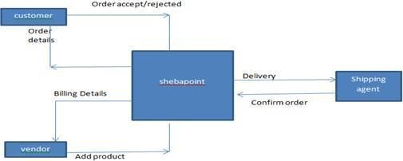

Figure3.5: Data flow diagram

**3.6 Er-diagram of the system**

Figure 3.6: Er-diagram

**3.7 Design requirement**

To develop this project, one had to first think of a design and then put it into account and then buy a specific theme from Theme Forest considering various HTML theme designs on the Internet, and later in the theme that carries C# made use of HTML CSS with the proper use of these projects. The design has been erected. This is a complete projector front end job and the back end SQL Server database is packing work band using the huge C Sharp's language.

**3.8 Summary**

In this part or chapter, we have discussed the full project using the use case diagram and data flow chart. We have also described them elaborately.

**CHAPTER 4**

**Design Specification**

For any kind of website, we have to design two parts. One is front-end design and another one is back-end design.

**4.1 Front-End Design:** We have used an HTML theme in this part and we usedjQuery for more effect and searching, going one page to another page, etc **[4]**.

**4.2 Back-end Design**

This part we design of the Backside of our system that can be viewed by the Dashboard of Admin Panel and Vendor Dashboard we use the Laravel framework for the backend.

**4.2.1 Admin Sign In page**

This is our admin sign in page. Admin can sign in from here.

Figure 4.2.1 shows the dashbord of the project

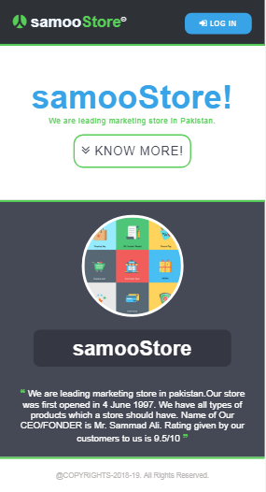

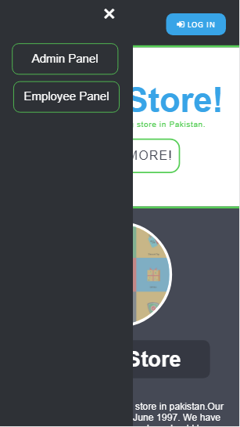

**4.2.2 Admin Sign In page**

This is our vendor sign in page. Vendor can sign into our system from here.

Figure 4.2.2 shows the AdMIN Sign-in page of the system.

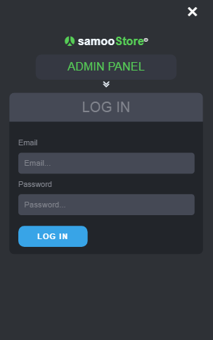

Figure 4.2.2: employee Login Page

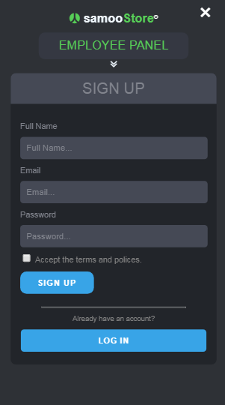



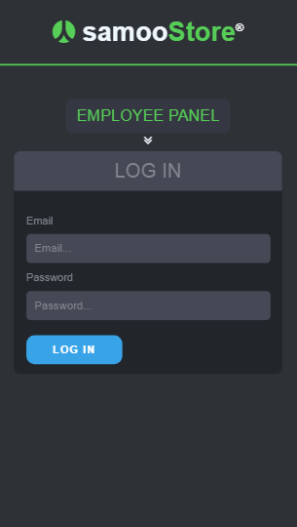

**4.2.3 Employee Dashboard**

This is employee dashboard

Figure 4.2.3 shows the Employee Dashboard.

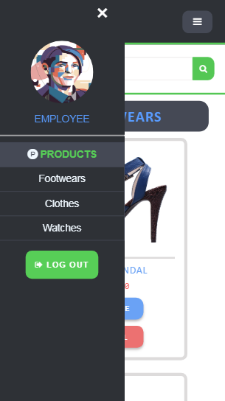  
  
  
  
  
  
  
  
  
  
  
  
  
  
  
  
  
  
  
  
  
  
  
  
  
  
  
  
  
  
this is Employee work where they can sell and calculate the quantity  
  
  
  
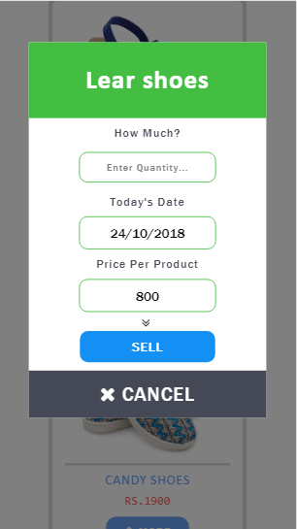

Figure 4.2.3: Admin and Vendor Dashboard Page

**4.2.4 Front Page**

In this part of 4.2.4, we show the front page. An Employee sell his/her desired products.

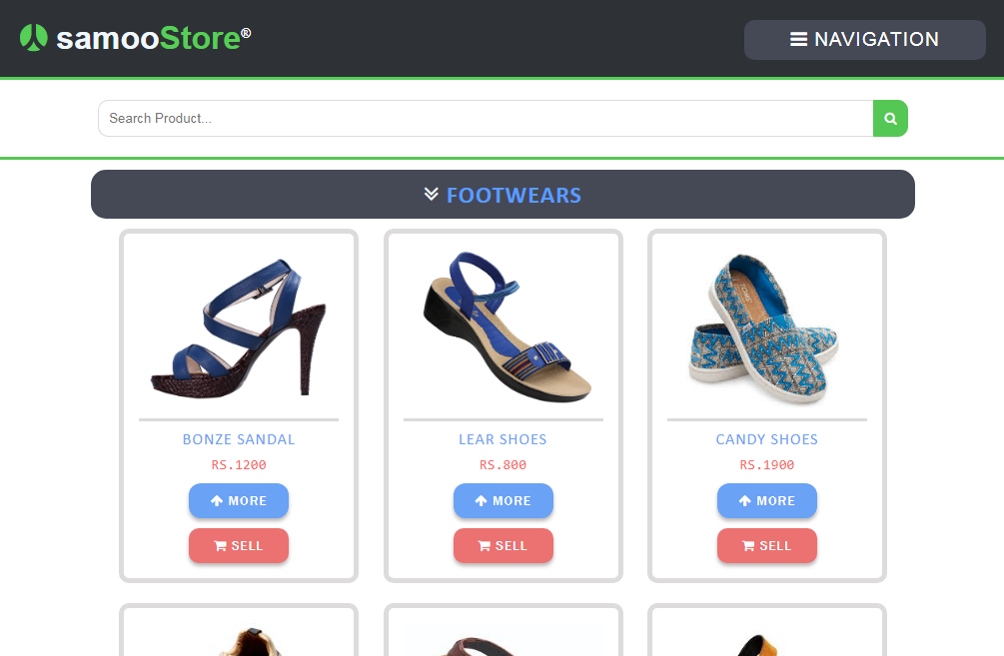  
  
  
  
  
  
  
  
  
  
  
  
  
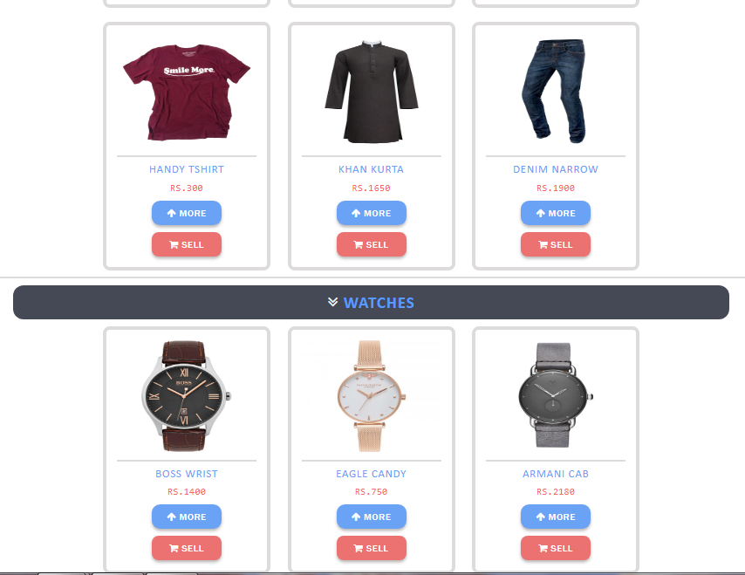

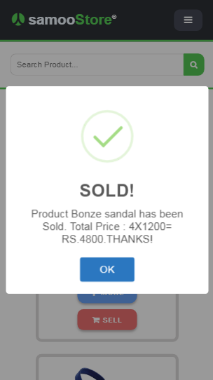  
  
  
  
  
  
  
  
  
  
  
  
  
  
  
An employee or shop owner can add or view products and quantities  
  
  
  
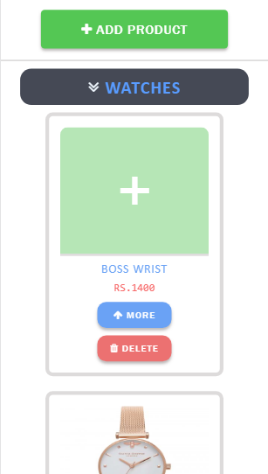  
  
  
  
  
  
  
  
  
  
  
  
  
  
they also can delete a product  
  
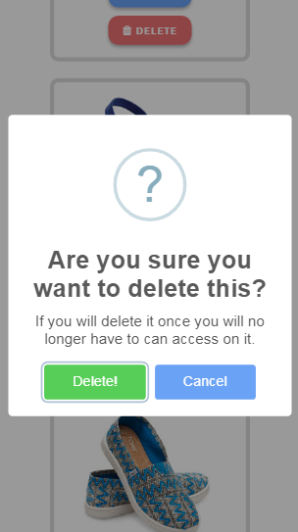

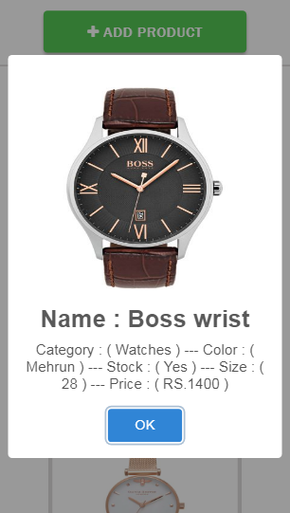

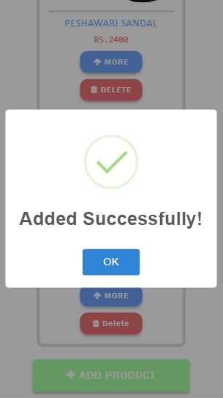  
  
  
  
  
  
  
  
  
  
  
  
  
  
  
  
  
  
  
They can add catagory wise products with their desirable variaties  
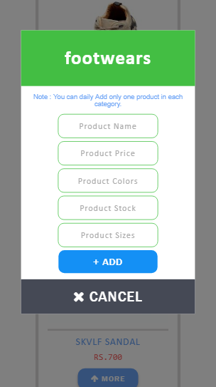

Figure 4.2.4: Front Page

**4.2.5 Sell and calculation**

Owner can Access in this section.The shop owner can see the sale of the day and calculate it

Figure 4.2.5 shows that Owner can see the sale and calculate in money

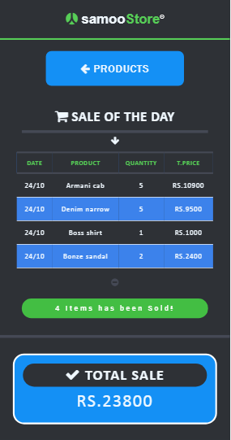

Figure 4.2.5: Category List Page

**4.2.6 catagory wise stock**

In this section owner can see the stock ctagory wise

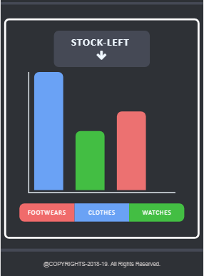

Figure 4.2.6: Product Upload Page.

**4.2.7 Order Confirmation sheet**

This is our order confirmation sheet. The admin can confirm all the orders of the customers from here. When a admin confirm the orders then the orders are shipped to the customers. Figure 4.2.7 shows the Order Confirmation Sheet page of the system.

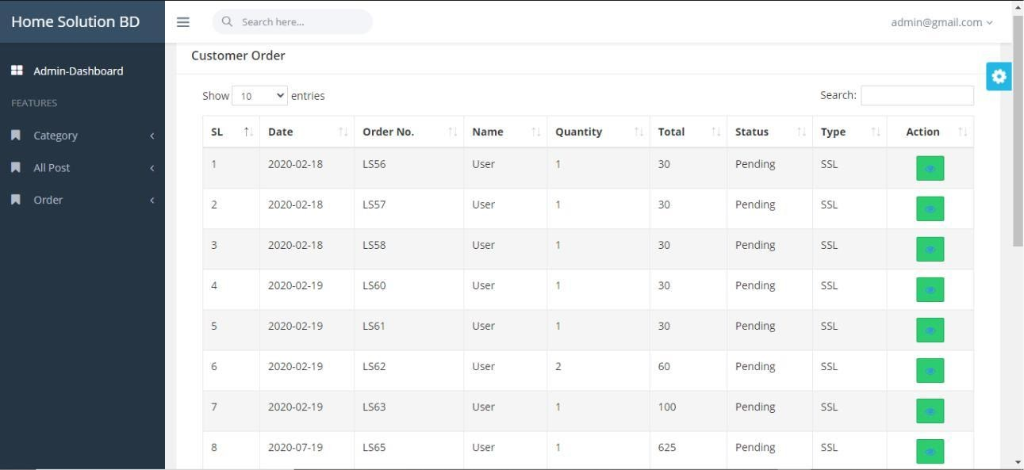

Figure 4.2.7: Order Confirmation Sheet Page

**4.2.8 Order Details Page**

This is our order details page. The admin can see the customer details and payment details from here. When a admin approve all the informations then the products are ready to be shipped to the customers.

Figure 4.2.8 shows the order details page of the system.

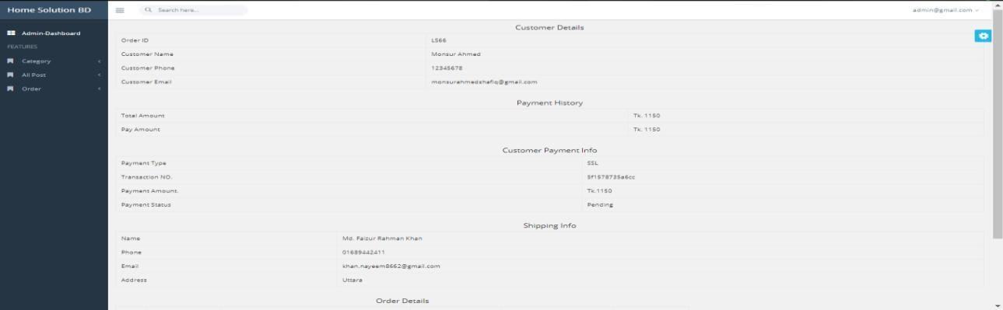

Figure 4.2.8: Order Details Page

**CHAPTER 5**

**Implementation and Testing**

**5.1 Introduction**

We'll be discussing how we apply this design in this chapter. In our project, we will include Front end & back end implementation. All the execution will be discussed with appearance with different figures.

**5.2 Database**

This is the database of our system. We have used My SQL for maintaining the database.

The part of 5.2 shows the backend database of our developed system **[1]**.

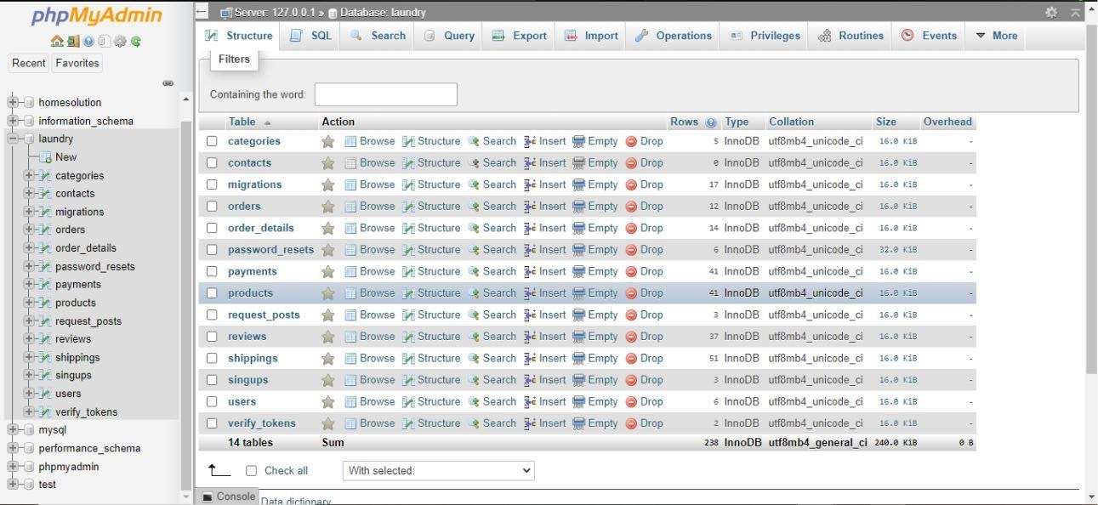

Figure 5.2: Database Connection

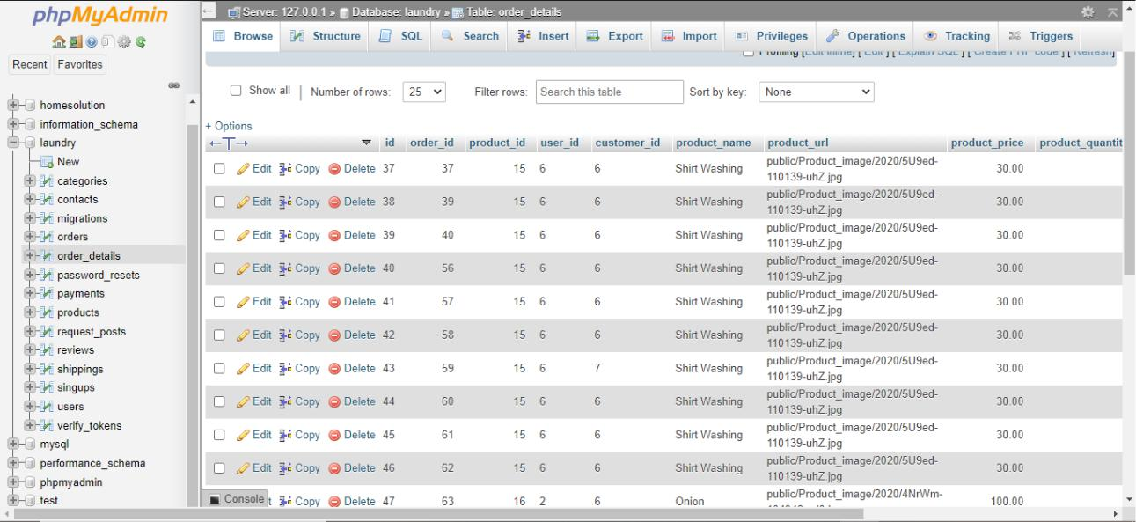

Figure 5.2: Database Connection

**5.3 Implementation of Back-end Design**

Our service program is an internet-based only. So that there are several working with the front layout. So for the internet-based challenges we’ve got HTML theme, CSS, jQuery for the front end execution **[3].**

**5.4 Test Execution**

For this is a web project that’s why testing is very much essential for this system to deploy the application. It will amount overall operational and could fix the knowledge that app by input and output measurement. On the other hand, a trial run may afford the feedback that however a good deal time they put uphold off to run and could enforce exact operation. There is systematic a lot of essays that could follow as a coating. As this coating, we have done some testing. They are given here:

**5.4.1 Unit Test**

This formula represents applied as when the code is applying then the-developer checked out since his own up first errors. So, in our case, we get ensured while we are doing code and arbitrated to discover the initial faults.

**5.4.2 Integration Test**

We integrated all back-end code and front- end. Then we have checked this and if any kinds of the layout are broken or not broken.

**5.4.3 Function Test**

Completely this serves that we selected for our covering at first. We have completed all initial prerequisites from these projects that require to be. And all the purposes are tried one by one. Because the roles are the main important part of a system. If the function does not exploit by rights and then the system will be wasted.

**CHAPTER 6**

**FUTURE SCOPE AND CONCLUSION**

**6.1 Conclusion**

In the conclusion, we just say about our project that is to manufacture such as a dynamic web application that will assist to oversee any kind of web system. We started thinking about almost this project last year. Later all by the grace of Allah we just create it. We just make these projects as the easiest way to manage any kind of web system. We think this application will be very helpful for people whole over the world. In the end, we want to tell something’s almost this project which was set up and accomplished to a good extent. From the first of this project, we just learn many things. We hope one day this application will be an almost popular application for any shopping website system.

**6.2 Scope for Further Development**

This project fills the primary quill requirements of a shopping web system. If we can provide the system in mobile applications than it will become easier for the user. We can allow information on the vendor and customer by their mail. As we know some kind of information can be updated. So, they can check their updated information. We already know that this system is only accessed by admin and vendors. So, we plan to do a customer access page for this system. The Web application has been developed executing the functionalities of the Multivendor Shopping website system.

**REFERENCES**

1. Sql Server available at <<https://www.microsoft.com/en-us/download/details.aspx?id=42299l>>, last accessed on 05/15/2020 at 03:00am.

1. HTML theme available at <<https://themeforest.net/category/site-templates>>, last accessed on 06-14-2020 at 02:00am.

1. CSS available at <[https://www.w3schools.com/css/default .asp](https://www.w3schools.com/css/default%20.asp)>, last accessed on 25-07-2020 at 01:00am.

1. jQuery available at <[https://stackoverflow.com](https://stackoverflow.com/)>, last accessed on 15-06-2020 at 11:00am.

1. Amazon website. Available at <[https://www.purchasecommerce.com/articles/multivendorecommerce-](https://www.purchasecommerce.com/articles/multivendorecommerce-marketplace-platform)

[marketplace-platform](https://www.purchasecommerce.com/articles/multivendorecommerce-marketplace-platform)>, last accessed on 07/23/2020 at 11:00pm.

[6]Alibaba website. Available at <<https://ads.alibaba.com/?spm=a2700.8293689.0.0.6ed567af4FUD1M>>, last accessed on 07/29/2020 at 11:00 pm. 

**PLAGIARISM REPORT**

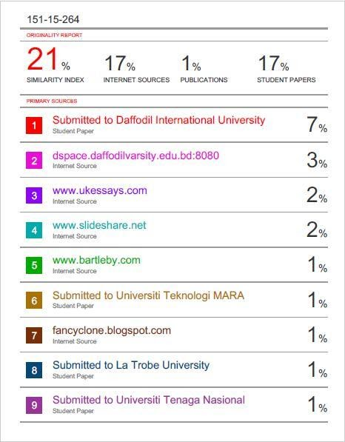

76

